Infection Control and Public Health Weekly Meeting
Thursday, February 12 | 12:30 – 1:00 pm

Hamilton County 2026-2028 Community Health Improvement Plan Priorities (Rebecca Stowe)
- Heart Disease and Stroke Prevention
- Suicide and Overdose Prevention
- HIV and STI Treatment and Prevention
- Housing (affordability, lead exposure, Public Health Nuisances)

Respiratory viruses: resurging
- Reports of fever, cough, and sore throat are rising again, as is typical when schools resume after the holidays.
- This increase is mostly driven by flu, especially among children. RSV is also contributing.

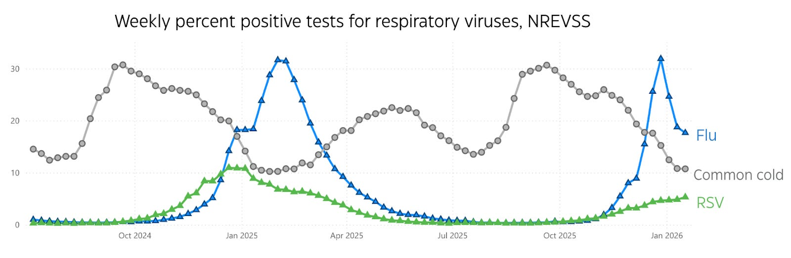

Respiratory Virus Season – Transition to Influenza A(H1N1) and Influenza B (Figure 1)
- Antigenic shift in influenza A(H3N2) from subclade J to subclade K (90%) which reduces the effectiveness of immunity from past infections and the current vaccine.
- Influenza A(H3N2) typically associated with more flu hospitalizations and deaths in adults
- Influenza A(H1N1) better match for immunity from vaccine and prior infection
- Influenza B more hospitalizations in pediatrics. Flu B often rises after flu A has already peaked, so a late-season increase like this is expected and not unusual.

Seasonal Influenza Vaccination
- Adult flu vaccination rate was 46.2% as of Jan. 24, up from 43.5% at the same time last season. Another 4.2% of adults report they still plan to get vaccinated this season.
- Adult flu vaccination declined steadily since peaking at 50.2% during the 2020–21 season.
- Pediatric flu vaccination rate is 45.4%, similar to last year’s rate at this time of 45.8%.
- Last season, the final estimated flu shot rate among children was 50.2%, the lowest level seen in at least 15 seasons.

Measles Cumulative Cases – Potential Loss of Elimination Status
- World Health Organization (WHO) announced six European countries lost their measles elimination status: Armenia, Austria, Azerbaijan, Spain, the United Kingdom, and Uzbekistan.
- Canada lost its elimination status late last year.
- WHO will examine the U.S. measles elimination status in April, and all signs point toward us losing it, which means measles is no longer a random event but endemic and freely flowing.

South Carolina Measles Outbreak
South Carolina outbreak is seeing fewer cases over time, and they have seen a 75% increase in MMR vaccination compared to last January. So, even a historically vaccine-adverse population are starting to come around to the importance of MMR.

FDA Declines to Review Moderna’s Application for First mRNA-Based Flu Vaccine
- Moderna has received a refusal-to-file letter from the FDA’s Center for Biologics Evaluation and Research for its biologics license application for mRNA-1010, its investigational seasonal influenza vaccine for age > 50.
- The company submitted two phase 3 studies supporting its application, including one with 43,808 participants.
- The vaccine has already been accepted for review in the EU, Canada and Australia.

Next Meeting … Thursday, February 26 (12:30 – 1:00 pm) … Will not meet on Thursday, February 19

Confirmed Influenza-associated Hospitalizations Southwest Ohio Region
Influenza A(H1) and Influenza B

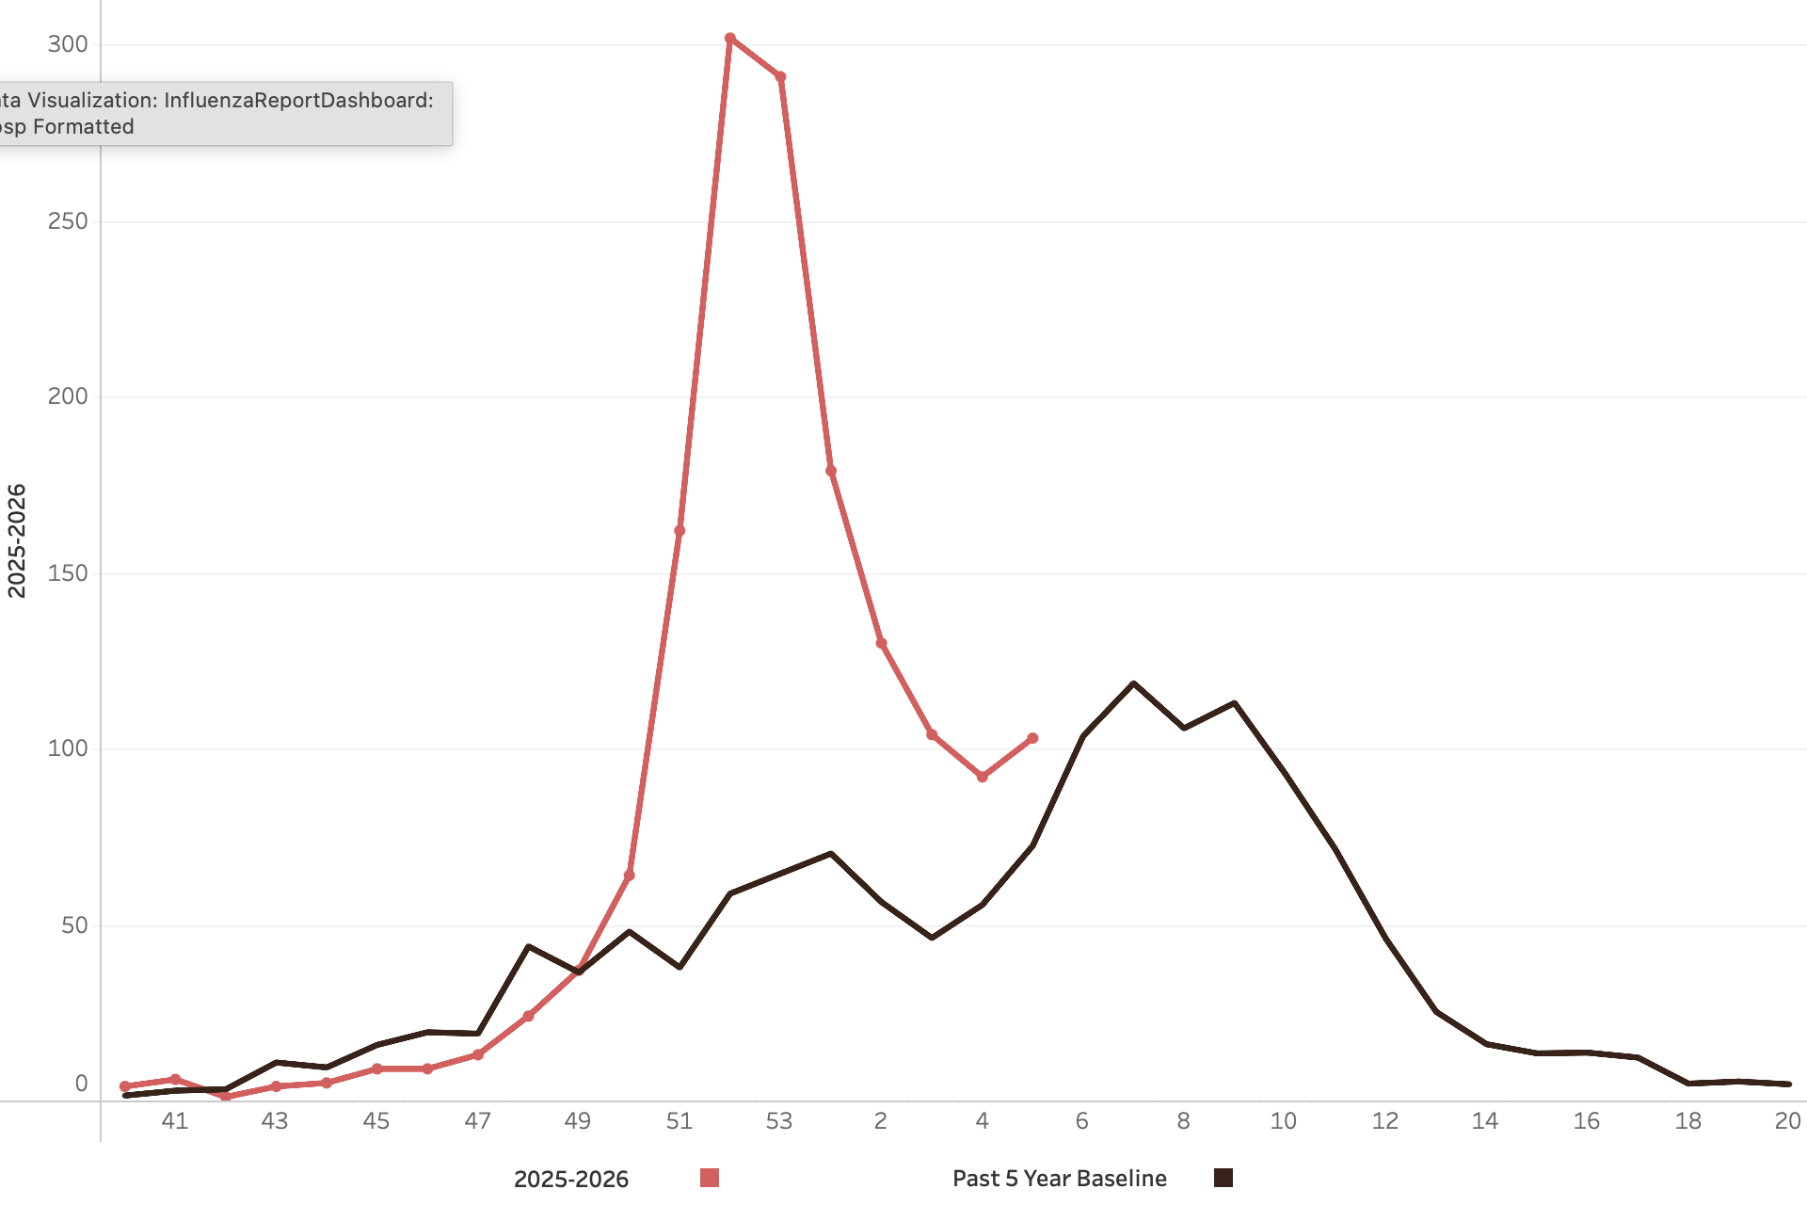
Updated Friday, February 13, 2026

Transition to Influenza A(H1N1) and Influenza B
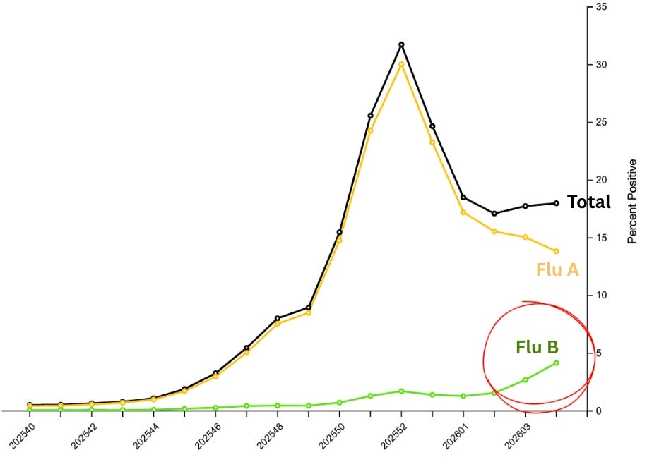

Pneumonia & Influenza Mortality State of Ohio
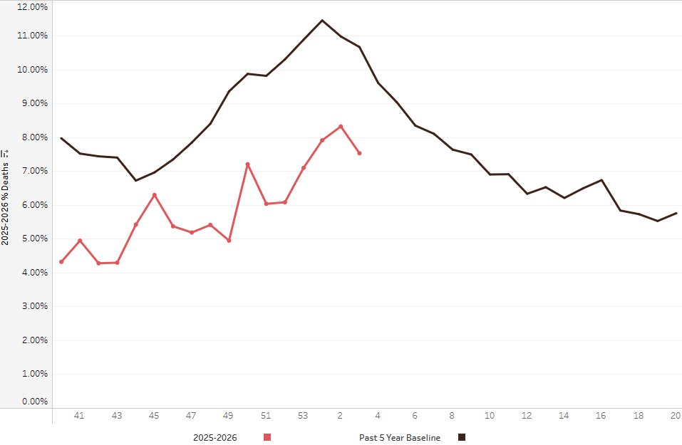

Percent Fever and ILI Specified ED Visits Southwest Ohio
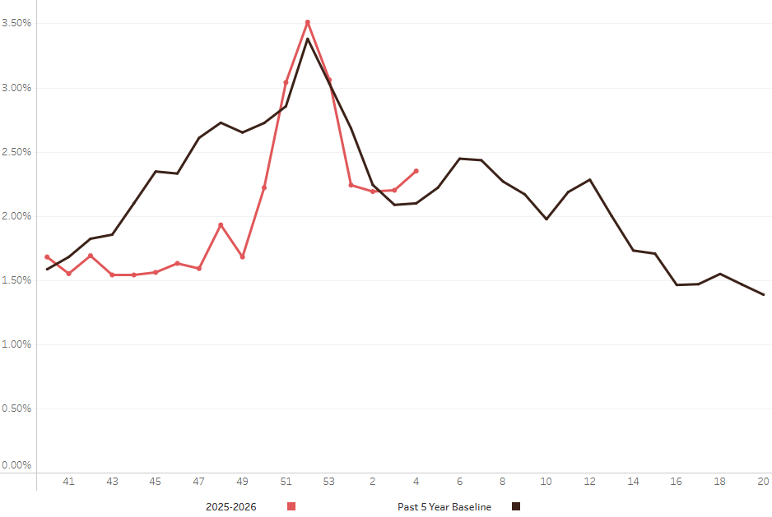

Percent of Primary Care Visits for Influenza Like Illness
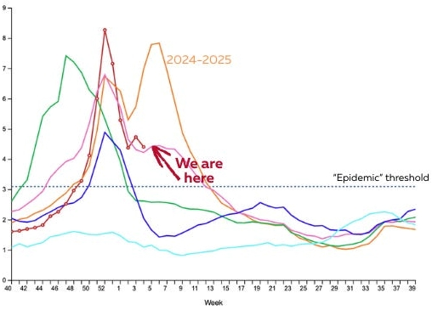

Measles Cumulative Cases by Year (as of Jan 29)
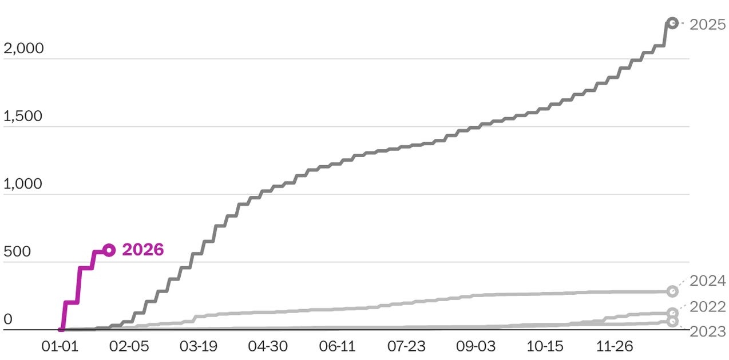


World Health Organization headquarters in Geneva … U.S. flag being lowered at the WHO as the U.S. officially departed.

